EARTHQUAKES IN THE NEWS
On October 18, 2023, residents in the Delta town of Isleton experienced an emergency warning about a 4.2 magnitude earthquake. The southern portion of Brannan Island was identified as the epicenter of the quake. The California Department of Water Resources (DWR) used this as an opportunity to reinforce their false narrative that earthquakes would cause massive Delta levees failures in order to justify the Delta Conveyance Project (commonly known as the Delta Tunnel).

REALITY
Recent earthquakes in the Delta do not justify construction of the Delta Tunnel. Instead, these natural events highlight that levees are more seismically resilient than DWR claims. The investment needed to improve the levee infrastructure system is a fraction of the cost of the Delta Tunnel (estimated at $2-3 billion).

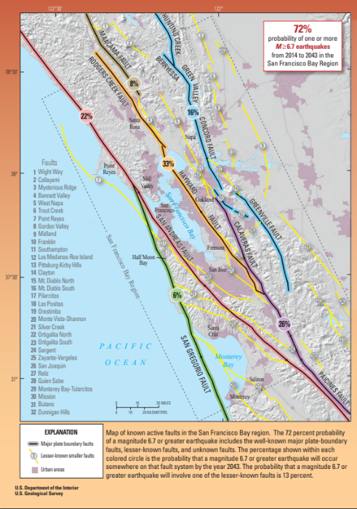
The Delta levee system protects critical access and movement of goods and commerce, prime agricultural lands, unique legacy communities, numerous recreational opportunities, ecosystem functions, while also supporting the Freshwater Pathway necessary for reliable export water supplies. The Delta is an important region to the State, not just for water, but for so many other unique inherent resources that make this place one of a kind that must be protected for future generations to enjoy.

THE FACTS

California Is an Earthquake-prone State and We Need to Be Prepared

Most of the Delta levees important to
state water supplies are over 30 miles
west of the San Andreas and Hayward
faults as shown in the USGS figure
below (see red and orange lines). (California’s own State Water Project
Figure: USGS Figure Showing Active Faults in San Francisco Bay Region
aqueduct built in the 1960s is adjacent
to and crosses over the San Andreas
fault, among many other faults as
discussed more below.)

DWR and State Water Project (SWP) contractors refer to a 2009 study that concluded that there was a 62 percent chance of an earthquake with a magnitude of 6.7 sometime in the Bay Area occurring between 2003 and 2032. In 2016, USGS revived the numbers indicating a 72 percent chance of a 6.7 or greater magnitude earthquake occurring in the Bay Area by 2043. According to DWR, this magnitude could cause levees to fail. The cited risk pertains to faults within the San Francisco Bay Region, not the Delta (e.g., the San Andreas and Hayward Faults). However, there is no discussion of attenuation once the earthquake reaches the Delta.

More recent reports suggest that distant Bay Area earthquakes pose less of a hazard to Delta levees than was previously thought and point out that average slip rates on the Midland Fault (nearer to the Delta) are less certain and have tens to hundreds of times slower slip rates than the San Andreas and Hayward Faults. Notably, none of the major Bay Area earthquakes, including the 7.8 magnitude earthquake in 1906 in San Francisco, the 6.9 magnitude earthquake in 1989 in Loma Prieta, or the 6.0 magnitude earthquake in 2014 in Napa, led to levee failures in the Delta. Additionally, levee failures also include slope slips, cracking, and crown settlement. What the State is inferring to are failures that lead to breaches and floods. However, a levee can fail and still not breach or flood. If water levels in the adjacent channel are at normal levels, the likelihood of a full breach from a levee failure due to liquefaction and subsequent crown settlement from an earthquake is low. The chances of large earthquakes resulting in major crown settlement occurring in multiple levees simultaneously as with a high-water event in the Delta are extremely low, exponentially less than 75 percent in the next 10 years. The justification to build a $20 to $50 billion dollar Tunnel project to mitigate such a low risk is misguided and an inefficient use of ratepayer and public funds.

The Delta Tunnel is not a rational response to earthquake risks. Recent small earthquakes with their epicenter in the Delta have allowed Delta levee engineers and other technical experts to assess in real time how levees respond to seismic activity, and to plan regular maintenance and repairs accordingly. In particular, the Brannan-Andrus Levee Maintenance District reviewed inclinometer data in a levee adjacent to the epicenter of the most recent earthquake, which recorded minimal movement (less than ¼ inch to 1 inch). Very little other damage was recorded. Past research by UCLA involved subjecting a model levee built with peat mixture to a 6+ magnitude earthquake, which also did not produce any evident damage.

The Levee System Is Key to Protecting Water Supplies, Other Statewide Important Infrastructure, and the Delta as a Place

Delta levees are part of an integrated system that protects Delta farms and communities, as well as over $60 billion of critical statewide-important infrastructure, including roads, highways, utilities, and shipping channels. In addition to the local region, this infrastructure also includes a Freshwater Pathway that benefits 27 million Californians south of the Delta, who rely in part on water from the Delta for their water supply.

Ongoing work on the Freshwater Pathway and other Delta levees has already greatly reduced risks of any outage for the export of water from the Delta to other parts of the state. Greater flood and earthquake preparedness includes levee improvements to widen and increase the height (“fat levees”), ensure stockpiles of emergency repair material, and integration of flood plans between local flood agencies and the state. Improvements to the levee system protect the state’s water supply while at the same time benefitting the Delta ecosystem, infrastructure, agriculture, and unique community. The Delta Tunnel would only benefit export water supplies, with unacceptable impacts to water quality and ecosystems that rely on fresh water flowing through the Delta.

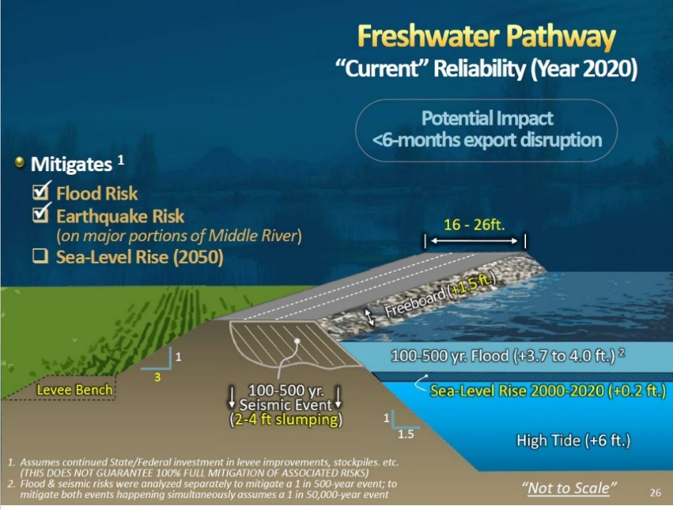
The state and local Subventions and Special Projects programs for Delta levees has been efficient and successful use of funding that has contributed to significant reduction in flood risk overall. In fact, the last failure that disrupted State water supplies was the failure on Brannan Island in 1972, over 50 years ago. With an average $22 million per year investment since the 1980s, the Delta levee system has seen vast improvements and increase resilience.
Figure: Metropolitan Water District Slide Showing Levee Improvements to Protect Freshwater Pathway

For about $2-3 billion (spent over 10-15 years), Delta levees could be improved to the baseline Bulletin 192-82 standard with a 24-foot-wide crown to further safeguard against potential earthquakes and sea level rise.

In addition, it is critical to:

  - Improve flood response through flood contingency maps, strategic staging of material stockpiles and equipment, and preliminary engineering designs in the event of failure for the Delta.
  - Invest in new technology that provides temporary means for raising levees and materials for controlling excessive seepage, blocking highway underpasses or gaps in secondary levees.
  - Create plans and procedures for emergency response and repairs to levees following an earthquake.
  - Use available technology to conduct more frequent and thorough inspections of the levees to identify and repair potential hazards.

Calls for a Tunnel to Address Earthquake Risk Ignore Needs of the Delta Counties and Delta Communities

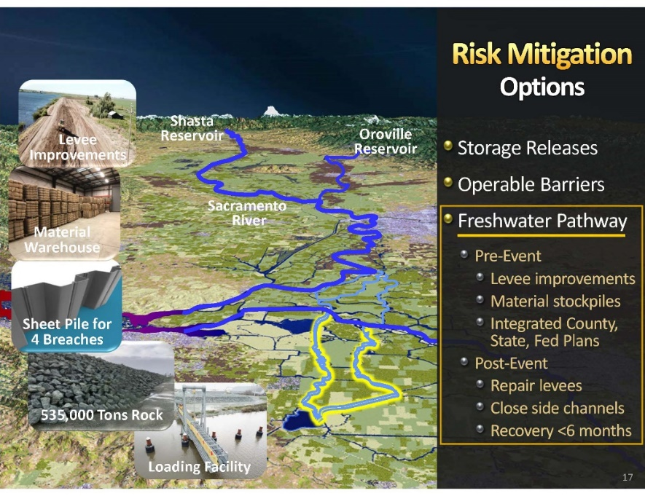
Even if a new Delta Tunnel could lessen the already small risk of a temporary outage of the state’s water exports from the Delta, the Tunnel would do nothing to protect Delta region or communities or the other statewide important infrastructure that traverses the Delta from earthquakes or other natural disasters.
Figure: Metropolitan Water District Slide Showing Freshwater Pathway and Emergency Response Elements

Most of the Earthquake Risks to the State Water Project Stem from Its Multiple Crossings of the San Andreas Fault.

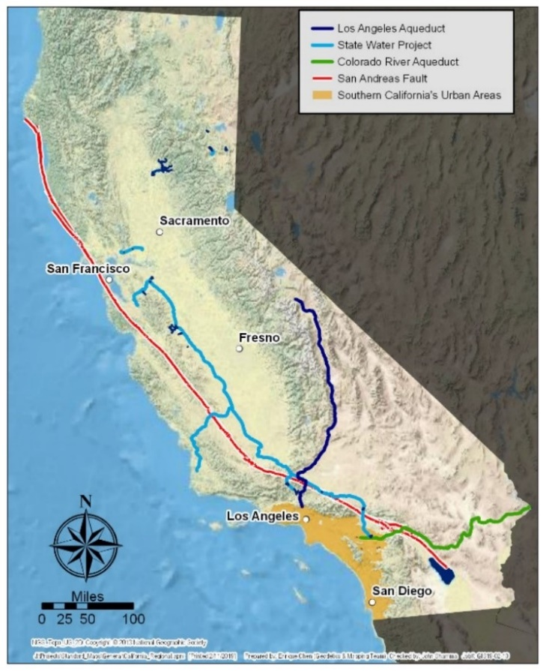
A new Delta Tunnel would not help make the hundreds of miles of delivery canals, sizable pumping facilities, and control structures, numerous electrical transformer stations and miles of electrical transmission lines more earthquake and disaster-proof. Failures in the delivery system due to land subsidence, earthquakes, terrorism and acts of war can result in contamination of the water supply or inability to deliver the supply. As shown in the figure below, existing water conveyance facilities cross the San Andreas fault multiple times on their way to deliver water to other areas of the state. A Delta Tunnel will not change the risk to that portion of the system. (The State Water Project was built and designed in the 1960’s prior to today’s modern seismic standards which have been developed over 50-years following every major earthquake. While it has seen damages due to subsidence, there’s no mention of plans to modernize and repair the whole system.) In other words, if the State of California is really worried about earthquake risk, it should turn its attention to its attention to the aqueducts as part of its own project that actually crosses the major fault lines.

Figure: State Water Delivery Systems in Relation to San Andreas Fault

It Is Critical to Reduce Reliance on the Delta for Water Supplies.

The 2009 Delta Reform Act included Water Code section 85021, which requires a reduction of reliance on the Delta for future water supply needs. Such a reduction in reliance also reduces the risk of temporarily losing access to Delta water exports.

The policy of the State of California is to reduce reliance on the Delta in meeting California’s future water supply needs through a statewide strategy of investing in improved regional supplies, conservation, and water use efficiency. Each Region that depends on water from the Delta Watershed shall improve its regional self-reliance for water through investment in water use efficiency, water recycling, advanced water technologies, local and regional water supply projects, and improved regional coordination of local and regional water supply efforts.

Continued investments in regional self-sufficiency are critical to water supply reliability for water districts throughout the state. Such self-sufficiency is essential to avoiding state-wide water supply disruptions for any reason. Investment in local supplies and self-reliance also builds within itself resiliency as well as sustainability, that are key to bridge extreme weather events and extreme drought. The Tunnel will not protect the State from extreme drought if it is operated in accordance with existing water rights and long-term agreements.

